**Deploying the static website in azure Storage account and ChatBot**

**Project overview:**Deploying the static website in azure storage account and chatbot.

**Project Goal:**

Deploying a responsive and user-friendly static website using Azure Storage Account with seamless chatbot integration for interactive user engagement and support.

**Project Scope:**

* **Static Website:** A website that consists of HTML, CSS, and JavaScript files. These files are pre-rendered and don't require server-side processing.
* **Azure Storage Account:** A cloud storage solution for storing large amounts of unstructured data, including text, images, videos, and more. It can also host static websites.
* **Azure CLI:** A command-line interface for managing Azure resources.
* **ARM Templates:** JSON-based templates that define the infrastructure to be deployed.

**Technologies and Azure Services Used:**

1. **ARM Templates:** Used to automate the deployment of resources including Azure Storage Accounts, Azure Bot Services for the static website and chatbot.
2. **Azure CLI:** Can be used in combination with ARM templates for initial setup or to perform additional configurations that are not covered by the ARM template.
3. **Azure Storage Account:** ARM template provisions and configures the storage account to enable static website hosting, including creating the $web container.
4. **Azure Bot Service:** provides a comprehensive environment for building, deploying, and managing chatbots. It includes integrated tools to handle both the backend and frontend aspects of chatbot development.
5. **Web Chat Channel:** Used to integrate the chatbot with your website or web application, enabling users to interact with the bot directly from a webpage.
6. **The Direct Line Channel:** provides a simple, secure communication line between the bot and external applications (like mobile apps or websites). It can be embedded into a website or mobile app for real-time chat functionality.

**Project Approach:**

1. Download and install the Azure CLI from the official website.
2. Login into the Azure portal by using the command az login.



1. Create a resource group using Azure CLI command.

[az group create - -name <resource-group-name> - -location <location-name>]

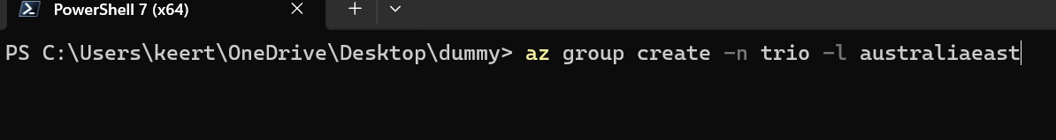

The resource group with “trio” is created in portal.

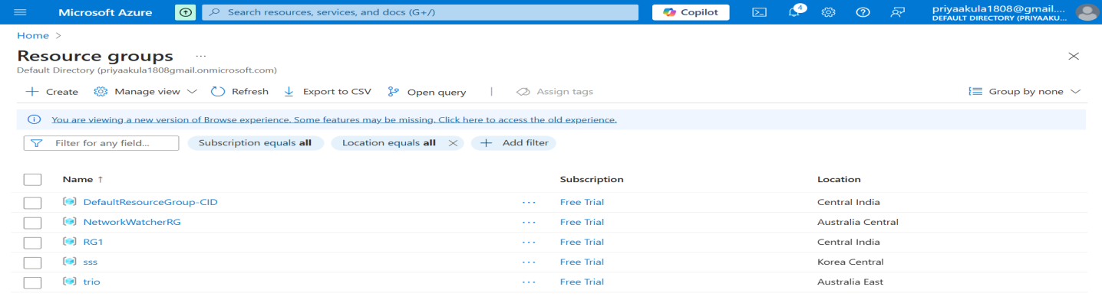

1. Create an ARM template by defining your infrastructure resources in a JSON format.

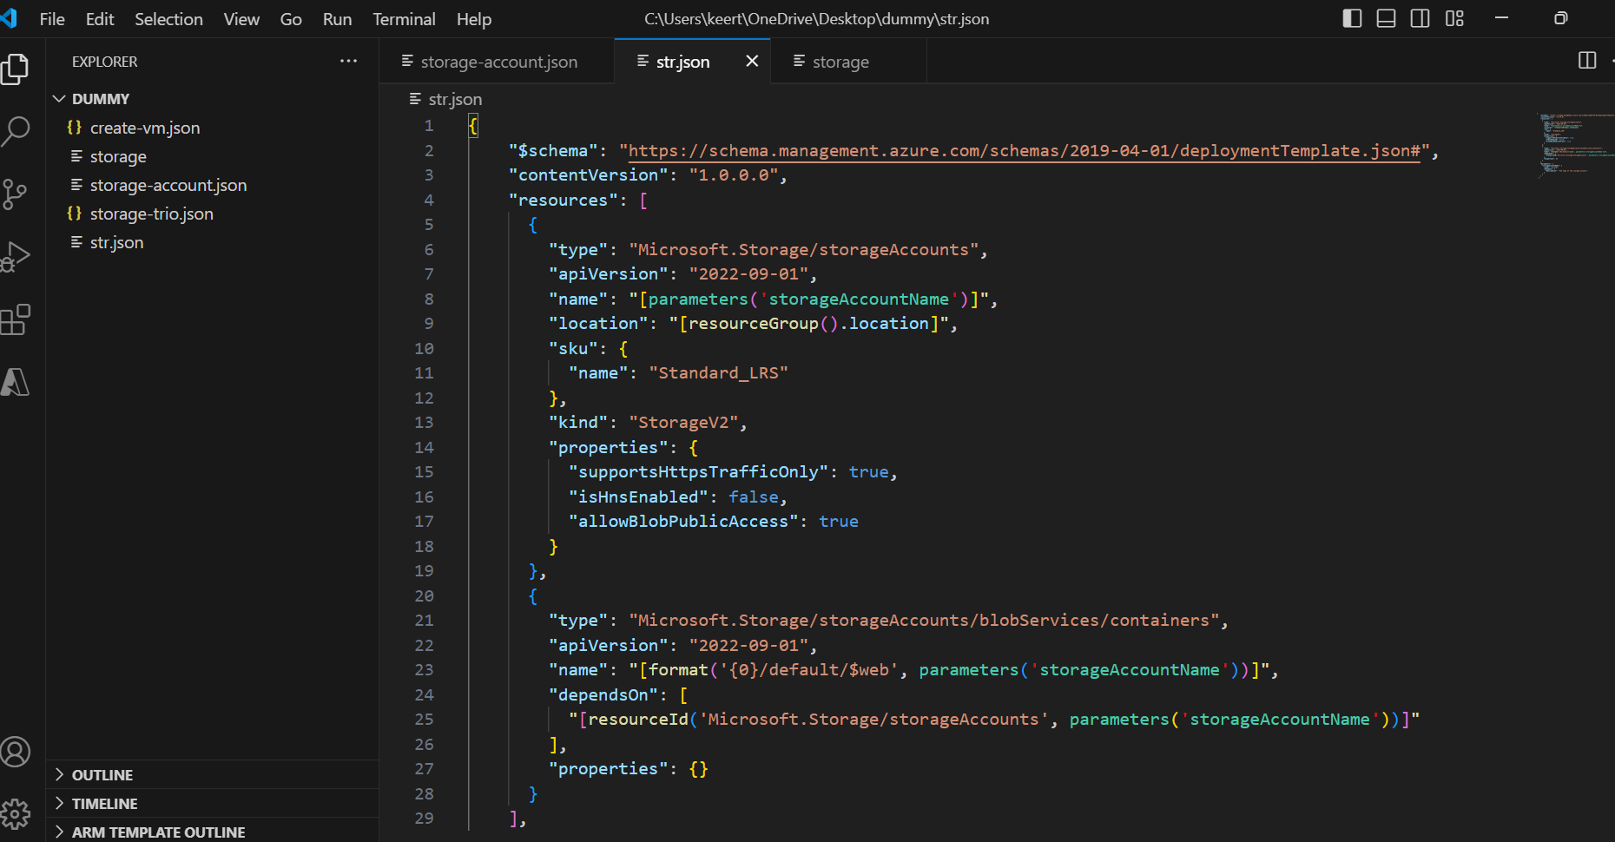

1. Deploy the ARM template by using Azure CLI command.

[az deployment group create --resource-group <RESOURCE_GROUP_NAME> --template-file storageAccountWithWeb.json --parameters storageAccountName=<STORAGE_ACCOUNT_NAME>]



The storage account “kkm12345” is created in the resource group “trio” in the azure portal.

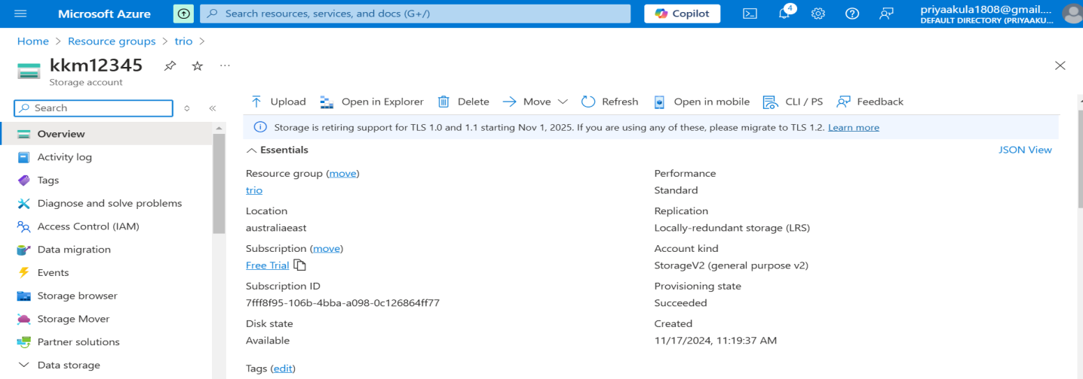

The container $web is created in the storage account “kkm12345”in the Azure portal.

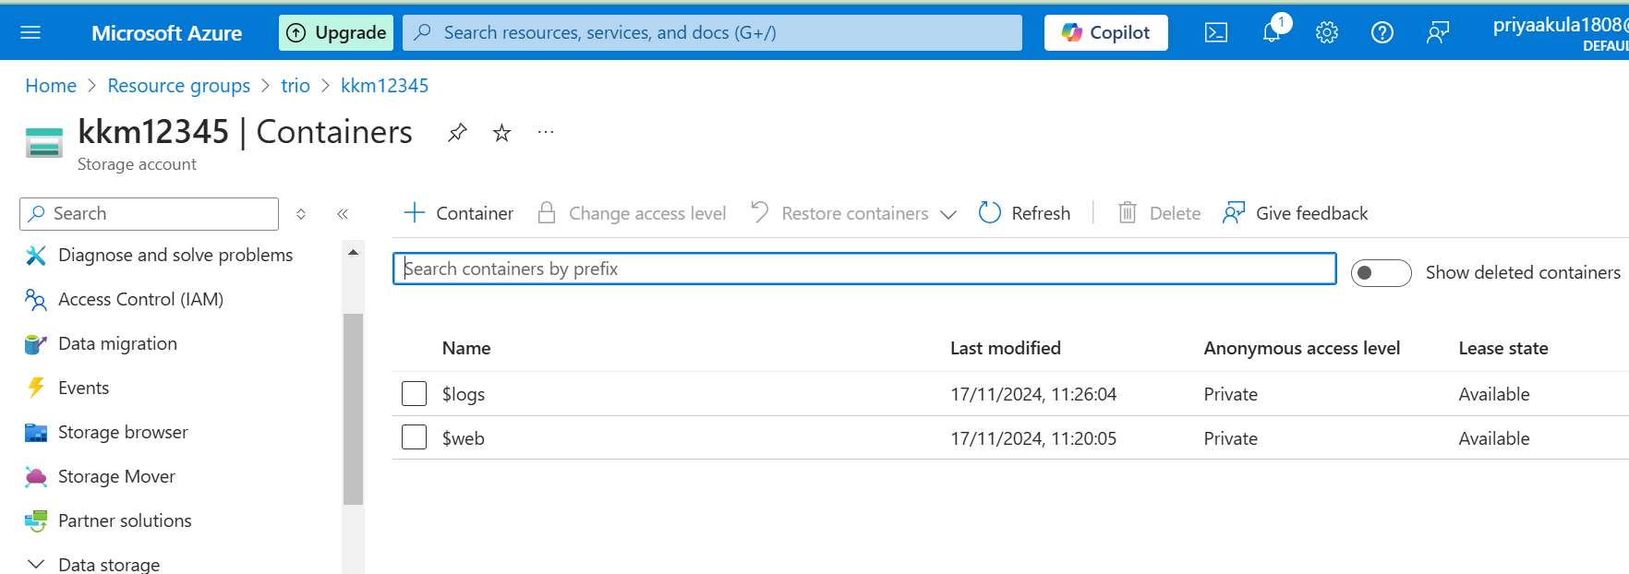

1. Enable the static website using Azure CLI command.

[az storage blob service-properties update --account-name <STORAGE_ACCOUNT_NAME> --static-website --index-document index.html ]

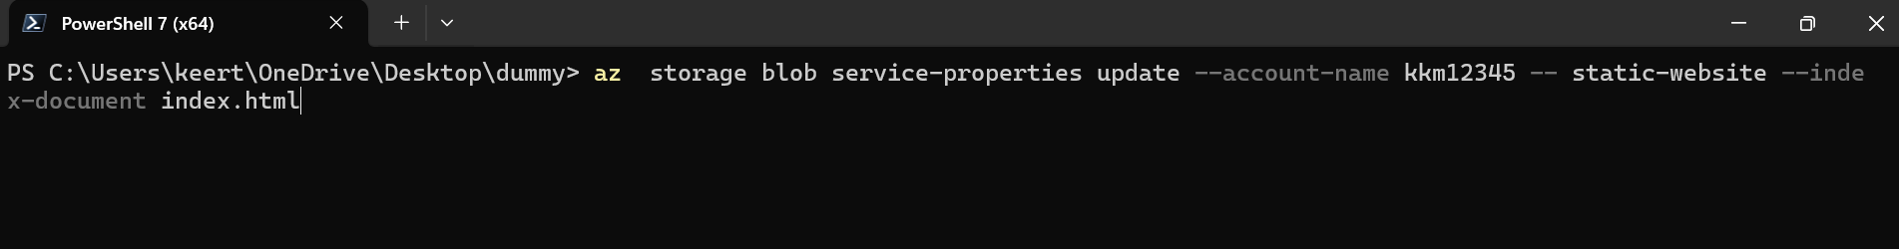

We can see the static website is enabled in azure portal.

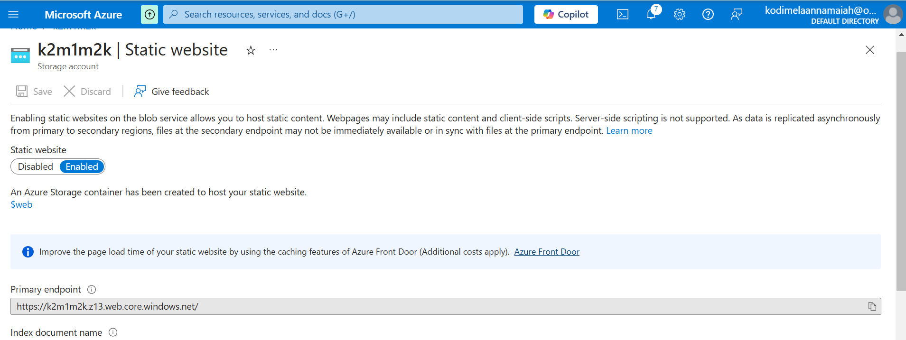

1. Upload the website file using Azure CLI command.

[az storage blob upload-batch --account-name <STORAGE_ACCOUNT_NAME> --source <SOURCE_DIRECTORY> --destination '$web']



When we open the azure portal we can see that the website files are uploaded.

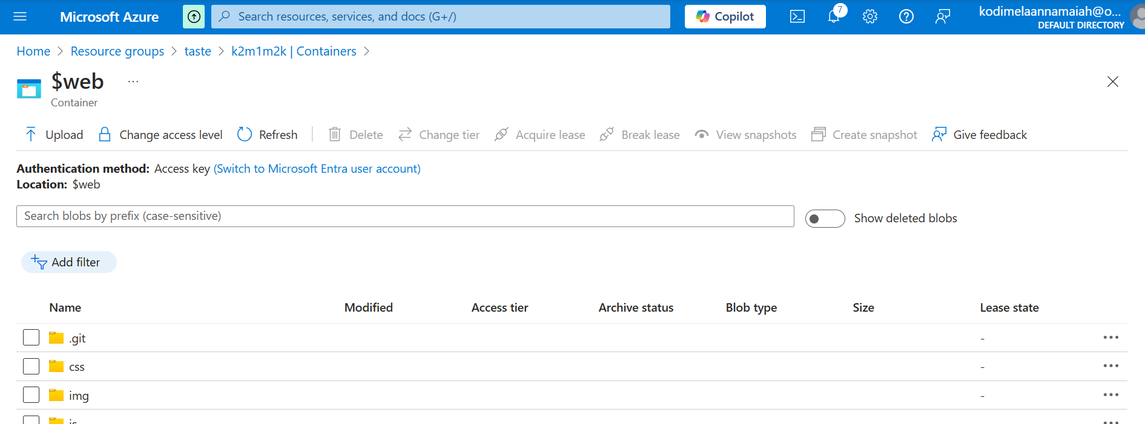

1. You can access your static website using the endpoint provided by Azure.Paste the endpoint in the browser.



When the private endpoint is pasted in the browser the website is opened as follows,

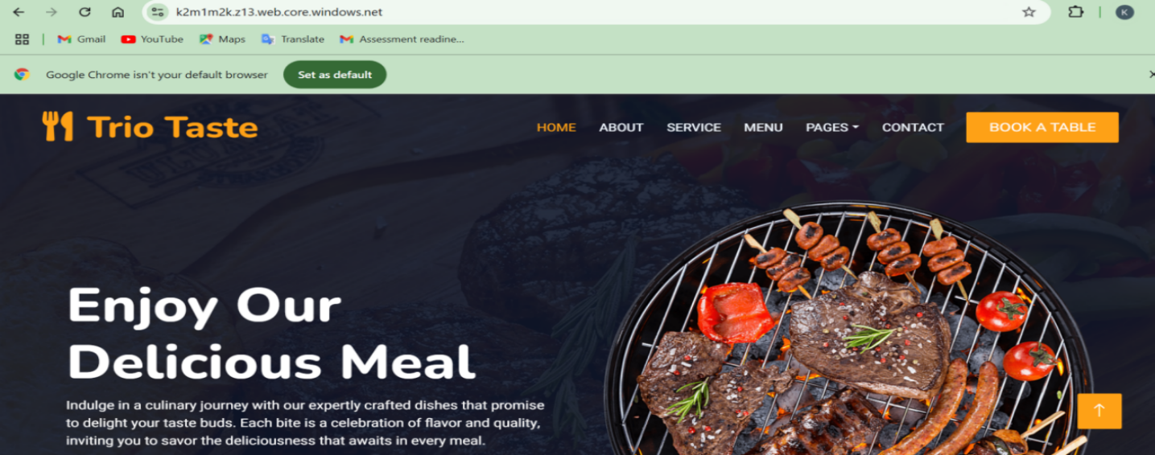

1. In Azure portal search azure ai services and create a language service.

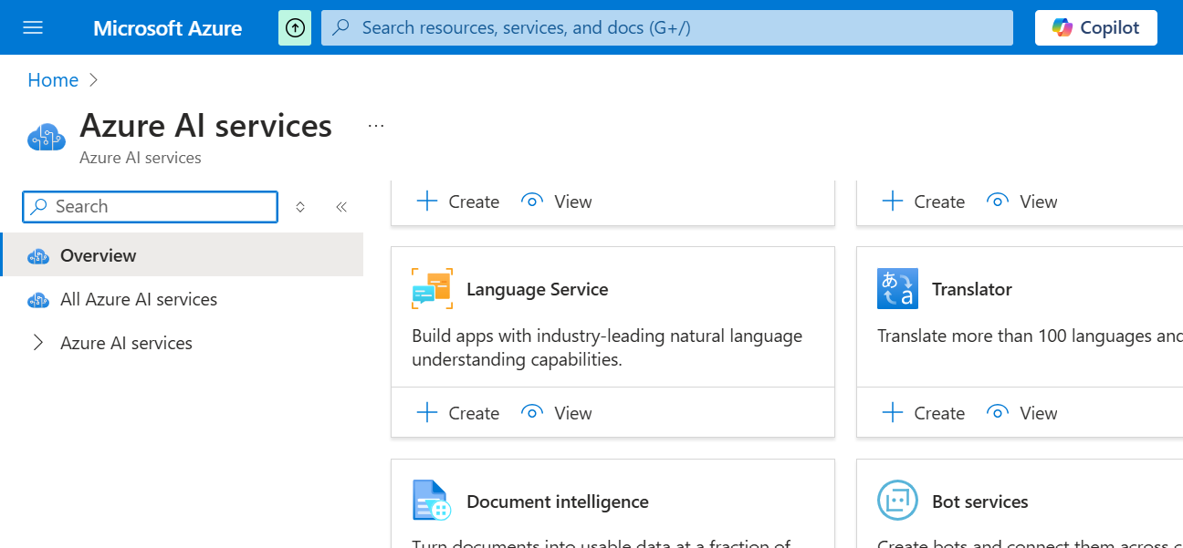

10.The language service “kkmlang” is created .

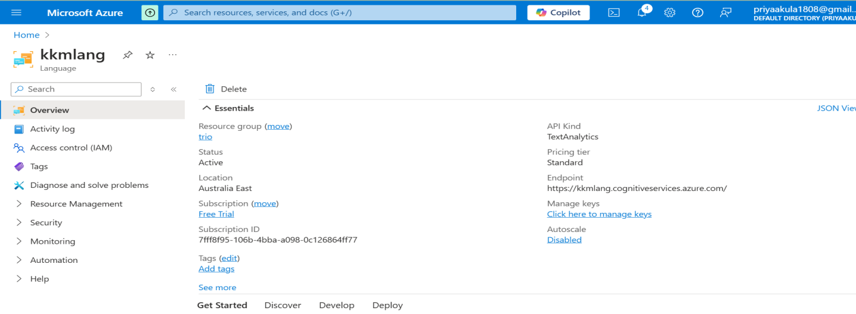

11.Create language studio in Azure portal.

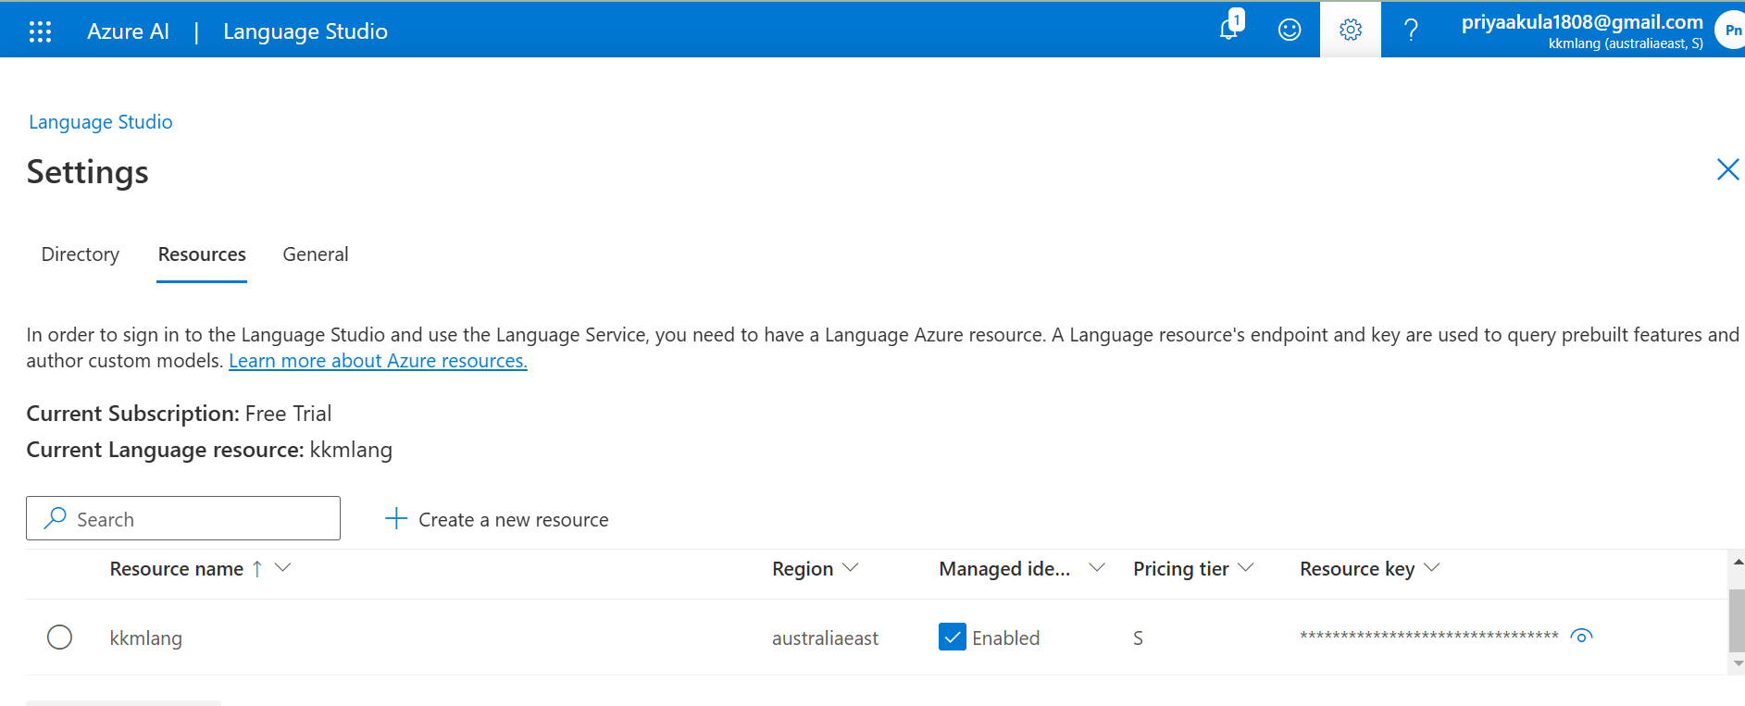

1. Deploy a file like excel sheet which contains question and answers.

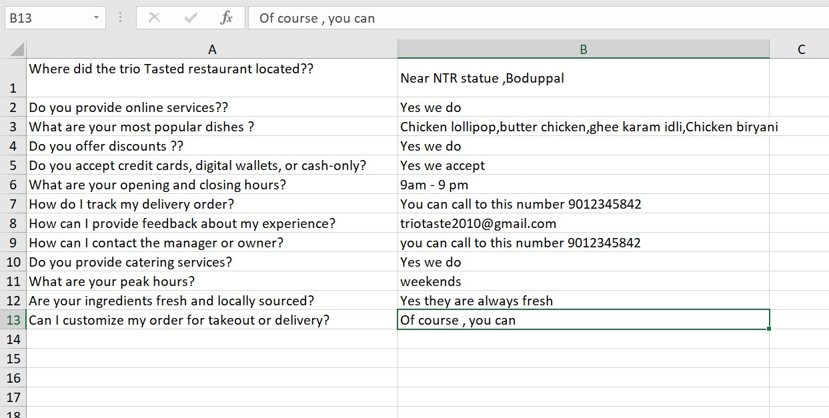

13.Navigate to channels section and click on web chat ,you will get a screate key and script copy them ,Then go to $web container in which it has index.html file paste the script and secrete key in that and save it.

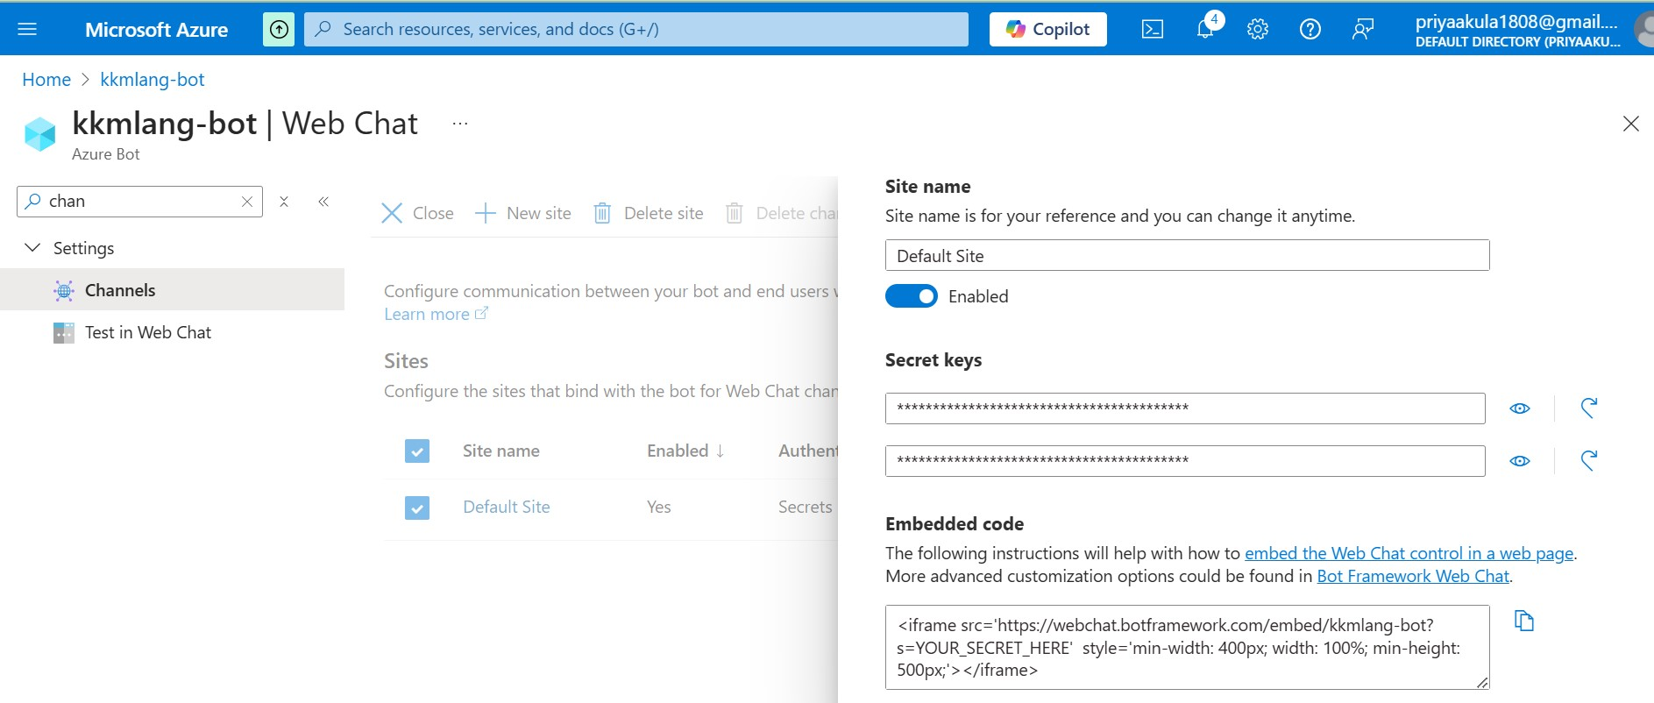

1. Paste the primary endpoint in the browser.



We wil get our website with chatbot option.

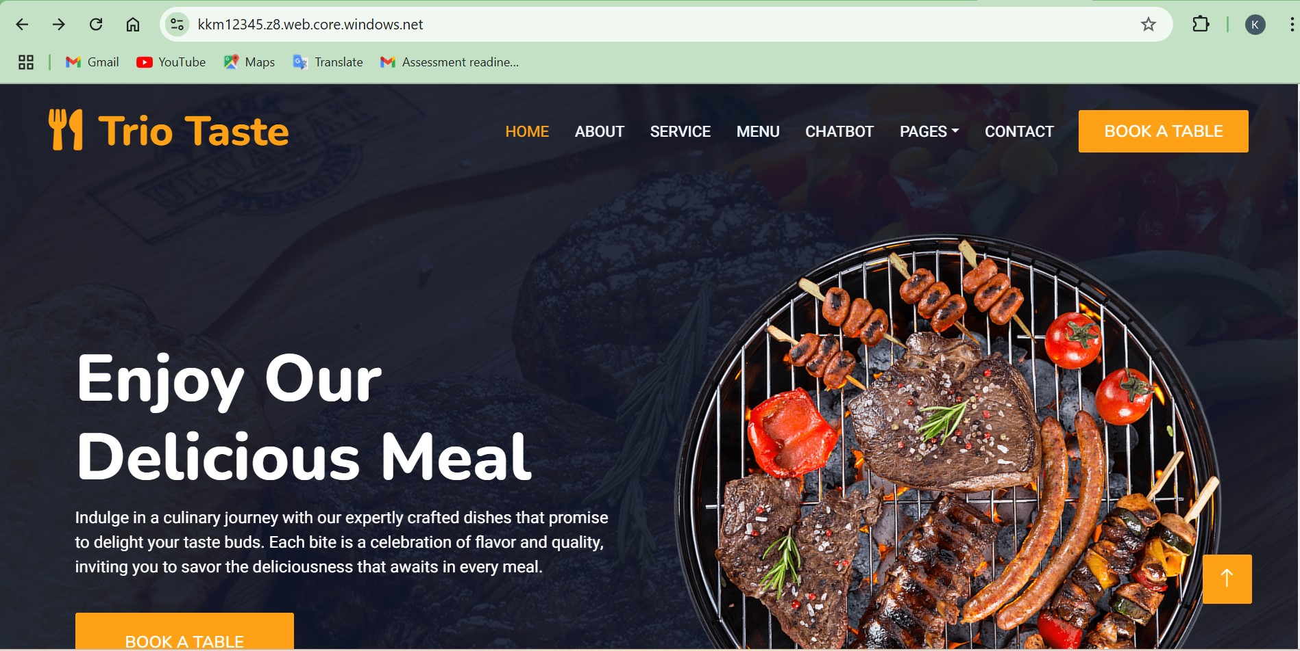

When we click on chatbot , and provide a question from excel sheet we will get as follows:

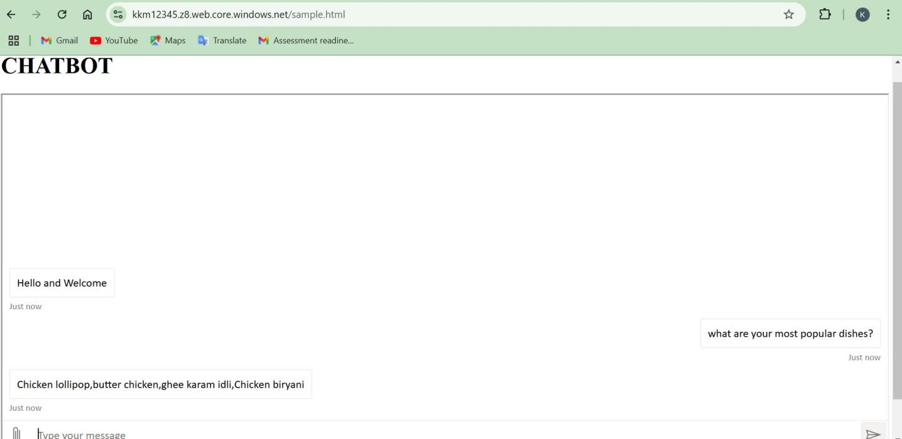

**Conclusion:**

In this project, we successfully deployed a static website in an Azure Storage Account and integrated a chatbot powered by Azure’s Language Services. This solution combines two powerful Azure services: Storage Accounts for hosting static web content and Azure Bot Services for building and deploying intelligent chatbots.